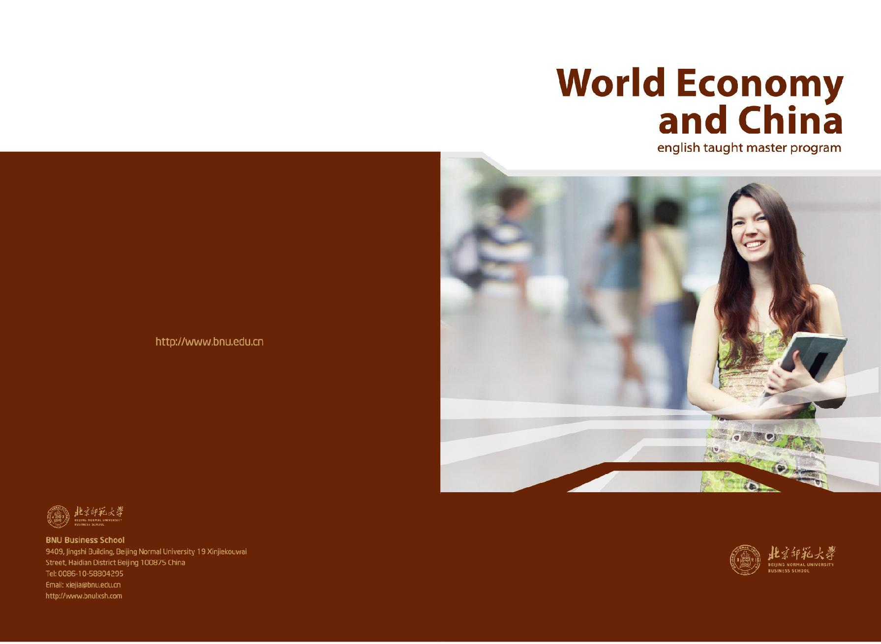

SECTION ONE

Getting Started
BEIJING NORMAL UNIVERSITY 1
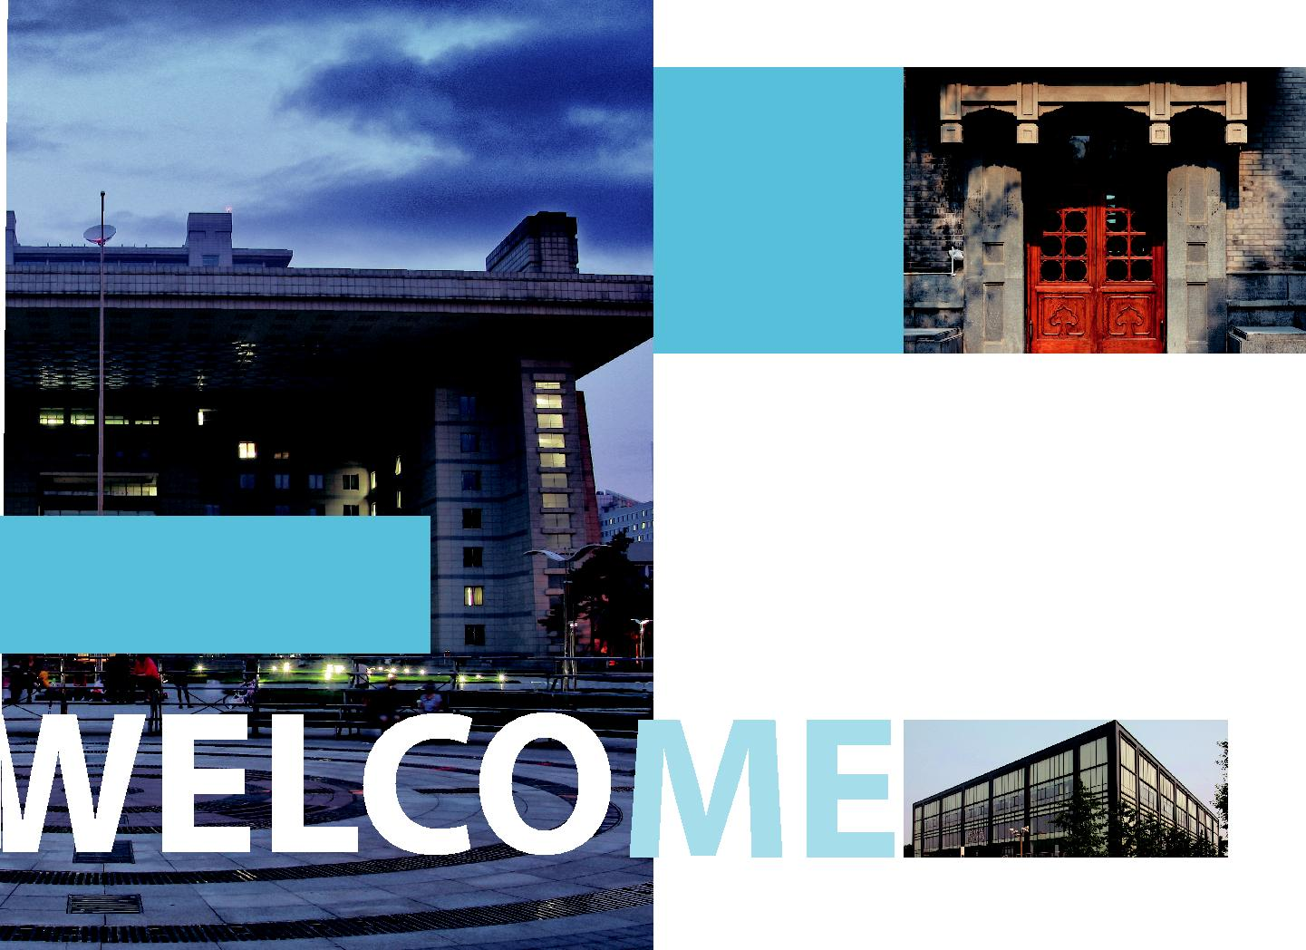

Introduction

Welcome to the Master program in World Economy and China at Beijing Normal University. We hope your study at BNU will be rewarding and your life in Beijing will be both enjoyable and exciting.

This brochure is intended as a full guide to the program, for potential students from all backgrounds who are interested in economics and China’s economy. You are welcome to read it carefully and refer to it if you have any questions. The curriculum is described, as well as the instruction and assessment methods, in addition to a set of brief syllabi for all courses.

If you have any queries after reading this brochure, please feel free to contact us at xiejia@bnu.edu.cn or by coming to visit our office in Room 9409, 4th floor, Jingshi Building on the main campus.

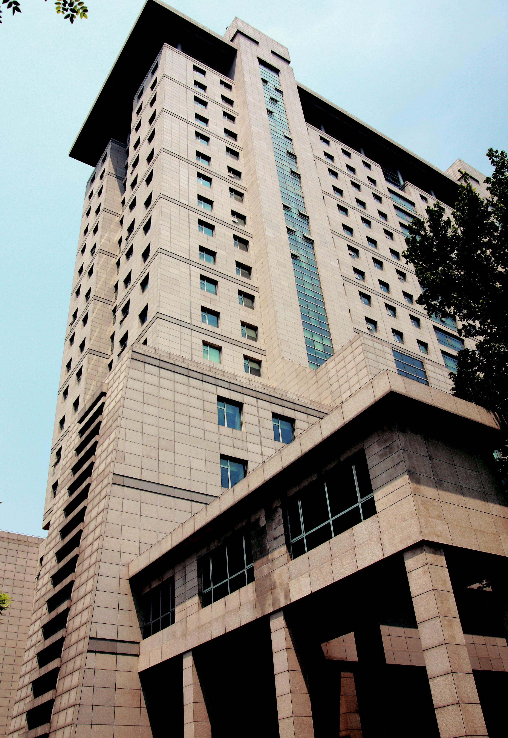
BEIJING NORMAL UNIVERSITY 3
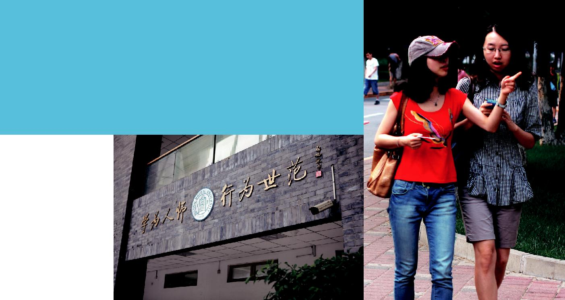

Aims and Objectives

The English Taught Master Program in World Economy and China is a two-year program with four semesters. In the first two semesters, there are approximately 4 months of lectures leading to an examination period toward the end of each semester; in the last two semesters, there is a combination of lectures and guided research dedicated to the graduation thesis.

We aim to provide students, who, preferably have but are not required to possess a background in economics and management from an undergraduate degree, with professional trainings in modern economics, including quantitative tools and techniques as well as theories and policy analysis, in addition to an opportunity to apply these in a piece of supervised research. Furthermore, we aim to offer a stimulating research-led environment where students work alongside leading researchers to develop the skills required to fulfill their aspirations to become professional economists, conduct further

research as PhD students, or become analysts on some other career path. Specially, unlike most other economic programs, we also aim to help our students to gain fundamental knowledge about China’s society, economy and culture.

At the end of the program you should be able to read and understand research papers and articles in academic journals, build basic theoretical models, initiate your own empirical research and evaluate its findings. The emphasis is not only on students having the opportunity to do real economic research, but also on helping to foster the growth of future business leaders with an international vision, multicultural communication skills, and modern management ability.

Our objective is to provide students with the essential training to pursue a career in economic analysis, apply economic knowledge in other fields, or further research towards a PhD degree.

