Seminar and expedition for
MBA students of the Beijing Normal University

Practically orientated seminar

- Program draft -

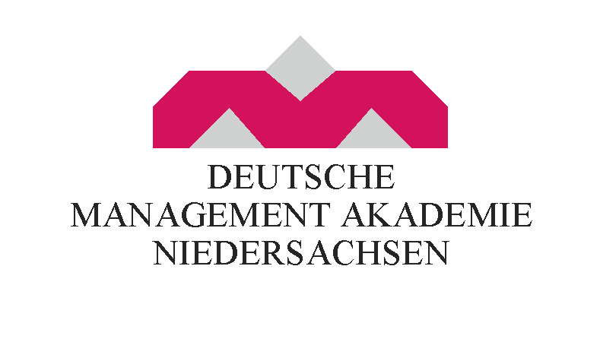

Program Schedule

Arrival | Arrival  Transfer to Celle  Companion: DMAN tutor
Day 1  09:00 h | Seminar at DMAN  Welcome Session  Mr. Harald Becker, Director International Relations,  Deutsche Management Akademie Niedersachsen
Afterwards | Lean Management  - Lean philosophy in context of modern management  - Lean Management in different companies and industries  - Competitiveness through the adaption of Lean Management  - 10 principles of the successful realization of Lean Management
12:00 - 13:00 h | Lunch at the DMAN Cafeteria
13:00 – 16:00 h | Planning and development of Lean Management in business processes  - Collaboration between departments according to the Lean principle  - Process and Product Validation  - Measurement and evaluation of the effectiveness of the Lean processes  Lecturer: Professor Dr. Peter Hohberger, University of Hanover, Faculty of Economics and Computer Science
16:00 h | Guided city tour through Celle
18:00 h | Welcome Barbecue at Waldcafé Müller in Celle

Day 2 | Seminar at DMAN  Companion: DMAN Tutor
09:00 – 12:00 h | Lean Management – Fields of application  - Lean Production  - Lean Development  - Lean Administration  - Lean Logistics
13:00 – 14:00 h | Lunch at the DMAN Cafeteria
15:00 – 16:30 h | Case Study – Lean Production  (Prof. Hohberger will allocate different case studies beforehand)  Lecturer: Professor Dr. Peter Hohberger, University of Hanover, Faculty of Economics and Computer Science
Afterwards | Freetime  Dinner individually

Day 3 | Company visits  Companion: DMAN Tutor
09:00-11:00 h | e. g. Visit of the Chamber of Industry and Commerce in Hanover  - Lower Saxon medium-sized businesses in China  - Encouragement of the Lower Saxon-Chinese communication  Head of Department II International Mr. Brunner
12:00-13:00 h | Lunch
14:00-16:00 h | e. g. visit of the Lower Saxon Ministry for Economy, Labor and Transport  - Lower Saxon economic relations with China  - German-Chinese economic cooperation  - the role of Lower Saxony in China  Head of Department 25 Mr. Pospich / Foreign Trade, Settlement, Marketing
Afterwards | Freetime in Hanover / Return upon consultation  Dinner individually
Day 3 | Company visits  Companion: DMAN Tutor
09:00 - 11:00 h | e. g. Company visit V-Line I  Innovative, middle-sized, owner-operated family business. The V-consortium is worldwide active as a service provider for the purchase of maintenance, reparation and servicing specific materials and components for industrial facilities of all kinds.
12:00 – 13:00 h | Lunch
14:00-16:00 h | e. g. Company visit Johnson Controls GmbH in Hanover  Johnson Controls is a global company with a diversified product and service offering with customers in more than 150 countries. The three scopes of Johnson Controls are: Building Efficiency, Automotive Experience and Power Solutions.  Technical discussion about Six Sigma Belt with the Business Development Department
Afterwards | Freetime in Hanover / Return upon consultation  Dinner individually
Day 5 | Company visit in Berlin  Companion: DMAN Tutor
In the morning | Check out of the hotel  Departure to Berlin by train and public transportation
 | Lunch
 | Check in to the hotel in Berlin
In the afternoon | e. g. visit of the headquarter of Deutsche Bahn AG  Presentation and information about the company Deutsche Bahn AG  Lecturer: Ms. Katja Klepper, International Business Development (non EU)
Afterwards | Freetime  Dinner individually
Day 6 | Cultural program in Berlin  Companion: DMAN Tutor
09:00 – 12:00 h | Berlin City Tour  - Brandenburg Gate (Brandenburger Tor)  - Holocost Memorial  - Berlin Cathedral
12:00 – 13:00 h | Lunch
13:00 h | Berlin City Tour  - Reichstag  - Siegessäule  - KaDeWe (Most popular shopping center of Berlin)
16:00 – 18:00 h | Freetime
18:00 h | e. g. Dinner Brauhaus (brewhouse) in Spandau:  With our quaint interior you can discover real brewhouse atmosphere in our Brauhaus in Spandau. During the whole year the guests can enjoy the in-house Spandauer Havelbräu. Thereto there is a special beer every month: in April, for example, the Mondschein-Bier (Moonshine-Beer), in August the Spandauer Landbier (Spandau Rural Beer) and in November the Herbstbock (Autumn Bock Beer).
Day 7 | Continuaion of the journey from Berlin to Wiesbaden by bus  Companion: DMAN Tutor
In the morning | z.B. Stopover in Potsdam and visit of the area around the Castle Sanssouci or Visit to the Movie Studios in Babelsberg, Potsdam
 | Lunch
In the afternoon | Arrival at the hotel in Wiesbaden  Dinner independently
Day 8 | e. g. Seminar at the European Business School, Wiesbaden  Companion: DMAN Tutor
09:00 – 12:00 h | Corporate Governance in Europe  - Relations between owners and managers of a company  - Structure of the relations in Europe
12:00 – 13:00 h | Lunch
13:00 – 16:00 h | - Analysis of the different Corporate Governance Systems in Europe  - Principal Agent Theory  - EU policy for the alignment of the systems
Day 9 | e. g. Company visit of the European Central Bank  (Europäische Zentralbank) in Frankfurt  Companion: DMAN Tutor
09:00 – 12:00 h | Visit of the European Central Bank (ECB) in Frankfurt  The European Central Bank is the most important financial instrument of the European Union. It was founded in 1998 by the EU and its head office is in Frankfurt, Germany.
12:00 – 13:00 h | Lunch in Frankfurt  Afterwards free time
18:00 Uhr | Dinner in Frankfurt  Return to Wiesbaden
Day 10 | e .g. Seminar at the European Business School, Wiesbaden  Companion: DMAN Tutor
09:00 -12:00 h | Supply Chain Management in Europe  - Optimizations of Supply Chains  - Outsourcing of business activities  - Aims and tasks of the SCM
12:00 – 13:00 h | Lunch
13:00-17:00 h | Best Practice example of the Supply Chain Management in Germany – a case study
Day 11 | Company visit by bus  Companion: DMAN Tutor
09:00 – 13:00 h | e.g. Company visit at Audi in Neckarsulm  Automobile manufacturer of high quality vehicles
13:00 – 14:00 h | Lunch in Heilbronn
14:00-16:00 h | Freetime in Heilbronn
16:00 h | Return to Wiesbaden
From 18:00 h | Farewell Dinner  with handover of the certificates
Departure | Return journey from Frankfurt  Transfer to the airport of Frankfurt  Companion: DMAN Tutor

Performance description

- Transfer from the Airport Hannover at arrival day to Celle accompanied by DMAN Tutor
- 12 Nights at a 3*** Hotel (German Standard) including breakfast
- DMAN Tutor will accompany the group during the whole Program/ From the day on in Berlin it will be a Chinese native
- 4 Day Seminar program consistent of lecturers, company visits and discussion organized by DMAN and a German University
- Entrance fee for various cultural activities and company tours, lump-sum 120 € per Person already calculated in the price. Residual amount will be paid back
- Including all transfers to the various destinations with private bus or public transport system, as well as transfer to the Airport in Frankfurt for Departure
- DMAN Certificate
- Welcome Barbecue
- Farewell Dinner
- Lunch on 4 Seminar days
- Language of the Program is English

Financial Offer

2.390 € per Person for 20 Participants
2.200 € per Person for 25 Participants
2.050 € per Person for 30 Participants

